**SIR APOLLO KAGGWA SCHOOLS**

**MID TERM II EXAMINATION 2024**

**PRIMARY FIVE**

**SOCIAL STUDIES & RELIGIOUS EDUCATION**

***Time Allowed: 2hours 15 Minutes***

**Pupil’s Name: …………………………………………..……………………**

**Class: …………………………………….………………………………………**

**School Name: ………………………………………………………………….**

|  |  |  |
| --- | --- | --- |
| **FOR EXAMINERS’**  USE ONLY | | |
| **Qn. No.** | **MARKS** | **EXR’S**  **No.** |
| **1 - 10** |  |  |
| **11 – 20** |  |  |
| **21 – 30** |  |  |
| **31 – 40** |  |  |
| **41 – 43** |  |  |
| **44 – 46** |  |  |
| **47 – 49** |  |  |
| **50 - 52** |  |  |
| **53 - 55** |  |  |
| **TOTAL** |  |  |

**Read the following instructions carefully:**

1. This paper has two sections: **A** and **B**
2. Section **A** has 40 questions (40 marks)
3. Section **B** has 15 questions (50 marks)
4. Answer all questions. All the working for both sections A and B must be shown in the spaces provided.
5. All working must be done using a blue or black ball point pen or ink. Any work done in pencil will NOT be marked except drawings and diagram.
6. Unnecessary changes in your work and handwriting that cannot be easily read may lead to loss of marks.
7. Do not fill anything in the table indicated

**“For examiners’ use only”** and the boxes inside the question paper.

***Turn Over***

**SECTION: A (40 MARKS)**

1. Why do people keep cows at home?

………………………………………………………………………………………………………………

1. 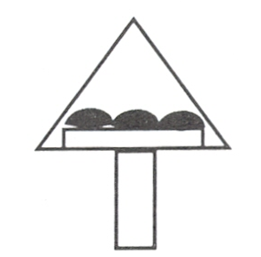Identify the map symbol below.

……………………………………………………………………………………………………………

1. Give one reason why your school has planted trees in the compound.

………………………………………………………………………………………………………………

1. Name any one tool that was used by the early man.

…………………………………………………………………………………………………………………

1. Write down any one lake in Uganda which is crossed by the Equator.

…………………………………………………………………………………………………………………

1. Why do people cut down trees in your community?

…………………………………………………………………………………………………………………

1. Why do farmers terrace their land in mountainous areas of Uganda?

………………………………………………………………………………………………………………..

1. Name the political area headed by the chairperson LCV.

………………………………………………………………………………………………………………..

1. State any one way the police keep law and order in the community.

…………………………………………………………………………………………………………………

1. Identify the first group of foreigners to come to Uganda.

…………………………………………………………………………………………………………………

1. Give any one type of fish caught in lakes and rivers in Uganda.

………………………………………………………………………………………………………………..

1. Which type of transport is commonly used by the people in Entebbe?

………………………………………………………………………………………………………………

1. What was the main reason for the coming of European explorers to Uganda?

…………………………………………………………………………………………………………………

1. What is a community?

………………………………………………………………..……………………………………………

1. What does the map symbol below represent?

……………………………………………………………………………

1. Write the ministry in Uganda which heads all schools.

…………………………………………………………………………………………………………………

1. Mention the type of family where we get the father, mother, children and other relatives.

……………………………………………………………………………………………………………….

1. Who was Kintu’s wife according to legends?

………………………………………………………………………………………………………………..

1. Name one landlocked country bordering Uganda.

………………………………………………………………………………………………………………..

1. Give the meaning of the word plantation vegetation.

…………………………………………………………………………………………………………………

1. Give one importance of shops to people of Uganda.

……………………………………………………………………………………………………………….

1. How were rift valley lakes formed?

……………………………………………………………………………………………………………….

1. Write RGS in full.

…………………………………………………………………………………………………………………

1. Which type of coffee does well on the slopes of Mt. Elgon?

…………………………………………………………………………………………………………………

1. Mention the Ethnic group which entered Uganda through North Eastern direction.

………………………………………………………………………………………………………………

1. Give any one reason why the Bantu settled around L. Victoria.

………………………………………………………………………………………………………………..

1. Mention any one element of weather.

………………………………………………………………………………………………………………..

1. Name the source of R. Nile.

……………………………………………………………………………………………………………….

1. State any one economic importance of hot springs.

…………………………………………………………………………………………………………………

1. Draw a map symbol for waterfalls.
2. Mention the type of rainfall which is commonly received in mountainous areas of Uganda.

………………………………………………………………………………………………………………..

1. Give any one product got from animal skins and hides.

…………………………………………………………………………………………………………………

1. Where does the compass needle always point when at rest?

……………………………………………………………………………………………………………….

1. Mention the department in the Uganda police that helps to control the flow of vehicles on roads.

……………………………………………………………………………………………………………..

1. State one right of a child.

……………………………………………………………………………………………………………..

**For questions 36 – 40 answer either Christianity or Islam But Not Both on the same number.**

1. **Either:** Name the holy book for Christians.

……………………………………………………………………………………………………………….

**Or:** Name the holy book for Muslims.

………………………………………………………………………………………………………………

1. **Either:** Name one Prophet in the Bible.

………………………………………………………………………………………………………………

**Or:** Name the Prophet in the holy Qur’an

………………………………………………………………………………………………………………..

1. **Either:** Write down the first man to be created by God.

…………………………………………………………………………………………………………………

**Or:** Name the first man to be created by Allah.

………………………………………………………………………………………………………………..

1. **Either:** Who died on the cross for our sins?

………………………………………………………………………………………………………………..

**Or:** Write down at least one pillar in Islam.

…………………………………………………………………………………………………………………

1. **Either:** State one activity done by Christians during lent period.

…………………………………………………………………………………………………………………

**Or:** Name any one activity done by Muslims during Ramadhan.

………………………………………………………………………………………………………………..

**SECTION B.**

1. a) What is climate?

…………………………………………………………………………………………………………………

b) Give any one aspect of climate.

…………………………………………………………………………………………………………………

c) Write down any one human activity that affects vegetation of an area.

………………………………………………………………………………………………………………..

d) Write down any one human activity that affects climate of an area.

……………………………………………………………………………………………………………….

1. a) **Study the map below of Uganda and answer the questions that follow.**

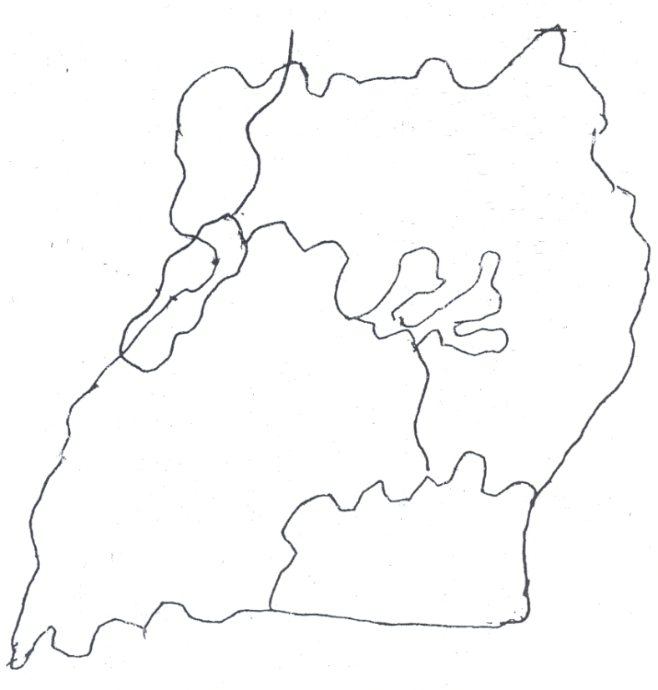

**C**

**B**

**D**

**A**

1. Name the capital city of the country marked C on the map above.

…………………………………………………………………………………………………………….

1. Which European explorer named the water body marked B above.

…………………………………………………………………………………………………………….

1. Name the water body marked with letter A above.

……………………………………………………………………………………………………………

1. Write the local name of mountain marked D above.

…………………………………………………………………………………………………………….

1. a) What is natural vegetation?

………………………………………………………………………………………………………………..

b) Which type of vegetation covers large areas of Uganda?

………………………………………………………………………………………………………………..

c) Give any one example of natural forest in Uganda.

……………………………………………………………………………………………………………….

d) Which type of wood is got from natural forests?

…………………………………………………………………………………………………………………

1. Match the following list correctly.

**List A List B**

Lake Katwe Gold

Albertine region Limestone

Osukuru hills Salt

Mubende Crude oil

1. Lake Katwe ………………………………………..…………………………………
2. Albertine region ………………………………………………………………..…………
3. Osukuru hills …………………………………………………………………………….
4. Mubende ……………………………………………………………………………
5. a) Give one reason why very many people in Uganda use road transport.

……………………………………………………………………………………………………………..

b) Mention the importance of a Zebra crossing to pedestrians.

………………………………………………………………………………………………………………..

c) Give one reason why water transport is not possible in Kotido district.

…………………………………………………………………………………………………………………

d) Under which type of transport do we put aeroplanes?

………………………………………………………………………………………………………………..

1. a) What are social activities?

………………………………………………………………………………………………………………..

b) Give any two social activities.

i) …………………………………………………………………………………………………………..

ii) …………………………………………………………………………………………………………..

c) Write down one reason why people carry out social activities.

…………………………………………………………………………………………………………………

1. a) Define the word physical features.

…………………………………………………………………………………………………………………

b) Which physical feature covers the largest part of Uganda?

………………………………………………………………………………………………………………..

c) How are lakes and rivers economically important to people?

…………………………………………………………………………………………………………………

d) Name the highest mountain in Uganda.

………………………………………………………………………………………………………………..

1. a) Mention the compass direction opposite to South East.

………………………………………………………………………………………………………………..

**Study the diagram below and answer the questions that follow.**

23½0N

X

00

23½0S

b) Name the line of latitude marked X.

…………………………………………………………………………………………………………

c) Give one importance of line of latitude you have mentioned in (b) above.

…………………………………………………………………………………………………………

d) Identify any one district in Uganda crossed by line of latitude X.

…………………………………………………………………………………………………………….

1. a**) Complete the table below correctly.**

|  |  |
| --- | --- |
| **Country** | **Capital city** |
| Uganda | ……………………………….. |
| ……………………………… | Nairobi |
| Tanzania | ……………………………….. |

b) Which country does Uganda border in the South?

…………………………………………………………………………………………..……………………

1. a) Identify any one symbol of a school.

………………………………………………………………………………………………………………

b) Why do school children wear uniforms?

………………………………………………………………………………………………………………

c) Give any two colours found on the Uganda National Flag.

i) ……………………………………………………………………………………………………………

ii) ………………………………………………………………………………………………………

**For questions 51 – 55, answer Christianity or Islamic But Not both in the same number.**

1. **Either:** a) Who is a martyr?

…………………………………………………………………………………………………………………

b) Who is believed to be the first Christian Martyr?

………………………………………………………………………………………………………………..

c) Why do we celebrate 3rd of June every year in Uganda?

…………………………………………………………………………………………………………………

d) Name the youngest Uganda Martyr who was killed in 1886.

………………………………………………………………………………………………………………..

**Or:** How were the people below related to Prophet Muhammad.

1. Aminah ………………………………………………………………………………………
2. Khadijah ……………………………………………………………………………………..
3. Abdallah ……………………………………………………………………………………..
4. Abubaker ……………………………………………………………………………………
5. **Either:** a) What is prayer?

………………………………………………………………………………………………………………..

1. Give three reasons why Christians pray to God.
2. ……………………………………………………………………………………………………
3. …………………………………………………………………………………………………..
4. ……………………………………………………………………………………………………

**Or:** a) What is salat?

………………………………………………………………………………………………………………

b) Give three reasons why Muslims pray to Allah.

i) ………………………………………………………………………………………………………….

ii) …………………………………………………………………………………………………………

iii) ………………………………………………………………………………………………………

1. **Either:** a) Name the first two sons of Adam and Eve.

i) ………………………………………………………………………………………………………….

ii) ………………………………………………………………………………………………………

b) Which son of Adam committed the first murder?

………………………………………………………………………………………………………….…

c) In which garden did Adam and Eve live?

……………………………………………………………………………………………………………

**Or:**a) Name the first two sons of Adam and Hawa.

i) …………………………………………………………………………………………………………

ii) ………………………………………………………………………………………………………….

b) Which son of Adam committed the first murder?

…………………………………………………………………………………………………………………

1. In which garden did Adam and Hawa live?

…………………………………………………………………………………………………………….

1. **Either:** a) On which day do Christians gather for prayers?

……………………………………………………………………………………………………………….

b) Name any two Christian holidays.

i) ……………………………………………………………………………………………………………

ii) ……………………………………………………………………………………………………………

c) Write one leader in Christianity.

…………………………………………………………………………………………………………………

**Or:** a) Name any two Muslim’s holidays.

1. ……………………………………………………………………………………………………………
2. ……………………………………………………………………………………………………………

b) On which day do Muslims gather for prayers?

………………………………………………………………………………………………………………..

c) Write down any one importance of praying together.

…………………………………………………………………………………………………………………

1. **Either:** a) What are gospel books?

…………………………………………………………………………………………………………………

b) Mention any three gospel books.

i) ……………………………………………………………………………………………………………

ii) …………………………………………………………………………………………………………

iii) …………………………………………………………………………………………………………

**Or:** a) Write down any two talents Allah has given people.

1. ……………………………………………………………………………………………………….
2. ………………………………………………………………………………………………………….

b) Mention any two leaders in Islamic religion.

i) ……………………………………………………………………………………………………………

ii) …………………………………………………………………………………………………………..

***“GOOD LUCK”***